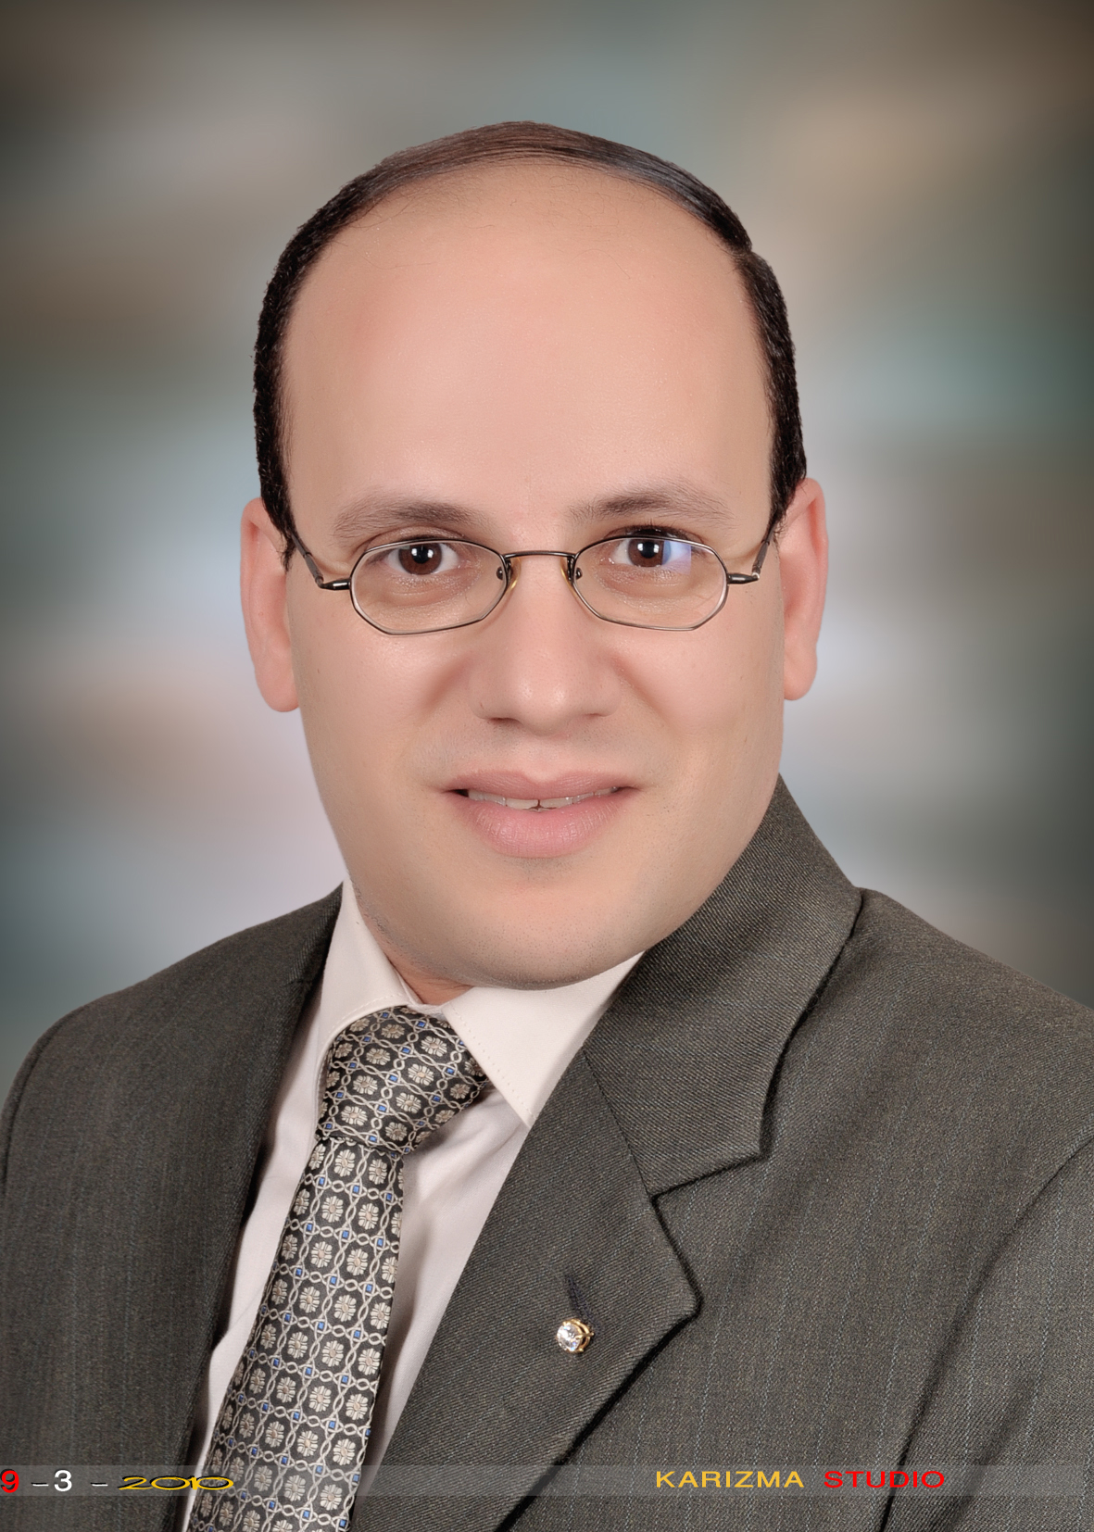
Curriculum Vitae

PERSONAL DETAILS
Name: Romany Helmy Thabit Gerges
Date and place of birth: 1/1/1973- Manfalout, Assiut, Egypt.
Marital status: Married and has 3 children.
Address: Assiut –Amin Osman, Al-Nemis St., Abdel-Mo’aty, Al-Rawi Building
Email Address: josefromany@yahoo.com
jcromany@aun.edu.eg
Telephones:
In KSA: 0536480245
In Egypt:
Home: 02/088/2313066
Mobile: 02/01016655960

Current position
Assistant Prof. of Pharmacology
Faculty of Medicine-NBU- KSA from 4-10-1434.

Degrees

Degree | Institution | Date
M.B.Ch.B ( Very good with honor )in medicine and surgery | Faculty of Medicine, Assiut University. | September,1996
M.Sc. (Very good) in Pharmacology. | Faculty of Medicine, Assiut University. | May, 2005
Doctorate degree (PhD) in Pharmacology | Faculty of Medicine, Assiut University. | January, 2010

Appointments

  - Assistant Prof. of Pharmacology, Faculty of Medicine-NBU- KSA from 4-10-1434 till now
  - Lecturer at Pharmacology Department, Faculty of Medicine-Assiut University from 28-2-2010
  - Assistant Lecturer at Pharmacology Department, Faculty of Medicine-Assiut University from 25-6-2005 till 27-2-2010
  - Demonstrator at Pharmacology Department, Faculty of Medicine-Assiut University from 17-4-1999 till 24-6-2005
  - Resident Physician at Pediatrics Department, Assiut University Hospital from 1-3-1998 till 16-4-1999
  - Trainee Physician at Assiut University Hospital from 1-3- 1997 till 28 -2- 1998

Experience
- Teaching:
  - Medical students in Faculty of Medicine-NBU- KSA
  - Experimental and clinical pharmacology to 3rd year undergraduate medical students
  - Experimental pharmacology to 3rd year undergraduate pharmacy students
  - Experimental toxicology, bioassay and biostatistics to 4th year undergraduate pharmacy students
  - Lectures of basic pharmacology to 3rd year undergraduate medical and pharmacy students
  - Lectures of toxicology and bioassay to 4th year undergraduate pharmacy students
  - Lectures of pharmacology to undergraduate nursing students
  - Experimental pharmacology and toxicology to undergraduate clinical pharmacy students
  - Lectures of pharmacology to postgraduate medical and pharmacy students
  - Lectures of pharmacology to postgraduate clinical pharmacy students
- Research interest:
  - Neuropharmacology
  - Immunopharmacology
- Others:
  - Good experience in research methodology and evidence-based medicine ( several workshops)
  - Experience in computer-aided programs e.g. SPSS and PRISM ( attained first part of doctorate degree in this field)
  - Based on the aforementioned experts, have the ability to write a sientific paper and performing the appropriate statistics ( significance tests, ANOVA, correlation tests,etc)
  - Good experience in putting course specifications in pharmacology, toxicology and bioassay and biostatistics for undergraduate and postgraduate medical , pharmacy and veterinarian sudents

Memberships

- Coordinator of pharmacology course in quality assurance unit at faculty of medicine, Assiut university ,Egypt
- Coordinator of pharmacology course in quality assurance unit at faculty of pharmacy, Assiut university ,Egypt
- Membership of egyptian medical syndicate from 3-3-1998

Authorship of books

Author of the recently published textbook titled fundamentals of medical pharmacology by Lambert Academic Publishing . March.2015

One of the authors of pharmacology depatment's textbook entitled " Essentials in pharmacology: Basic and Clinical " for 3rd year medical and pharmacy undergraduate students in faculty of medicine- Assiut university-Egypt.
Conferences:
- Successful presentation of an oral research entitled “Characteristics of Anti-inflammatory and Anti-Rheumatic effects of rolipram” in 7th international conference of pharmaceutical sciences in faculty of pharmacy, Assiut university on 17-18 March 2010.

- Accepted poster presentation entitled “Influence of dipyridamole and its combination with nitric oxide donor and nitric oxide synthase inhibitor on adjuvant arthritis” in Annual conference of faculty of medicine, Assiut University on 20-23 March 2010.
Publications:
  - Genetic variants in 6-mercaptopurine pathway as potential factors of
hematological toxicity in acute lymphoblastic leukemia patients. accepted for publishment in pharmacogenomics journal . 2015
  - ''Genotyping analysis of TPMT and ITPA variants in Egyptian pediatric patients with acute lymphoblastic leukemia and its association with 6-mercaptopurine-related myelotoxicity'' Fundamental and Clinical Pharmacology © 2014 Soci_et_e Franc_aise de Pharmacologie et de Th_erapeutique, 28 (Suppl. 1), page 38
  - L-arginine and aminoguanidine reduce colonic damage of acetic acid-induced colitis in rats: Potential modulation of nuclear factor-kappa B/p65. Clinical and Experimental Pharmacology and Physiology (2014) 41, 769–779
  - M.Sc. degree thesis : " Effect of adenosine receptors modulation on neurological actions of theophylline in animals ", Assiut university, Egypt, 2005
  - Doctorate degree thesis : " Investigation of the therapeutic potential of phosphodiesterase inhibitors, nitric oxide donors and their combination in treatment of autoimmune diseases : rheumatoid arthritis as a paradigm" Assiut university, Egypt, 2010
  - Influence of dipyridamole and its combination with NO donor or NO synthase inhibitor on adjuvant arthritis. International Immunopharmacology 10 (2010) 1406–1414.
  - Dual effect of nitric oxide donor on adjuvant arthritis. International Immunopharmacology 9 (2009) 439–447.
  - Enhancement of the anti-inflammatory and anti-arthritic effects of theophylline by a low dose of a nitric oxide donor or non-specific nitric oxide synthase inhibitor. British Journal of Pharmacology (2009), 158, 1835–1847.

Supervision of research project
  - Supervisor on doctorate degree thesis of the assisstant lecturer Mohammed Salem Haredy at pharmacology depatment, Assiut faculty of medicine, Egypt.
  - Supervisor on Master degree thesis of the demonstrator Nahla Ibrahim Ahmed at pharmacology depatment, Assiut faculty of medicine, Egypt.

References
  - Prof.Dr. Frag Mohammed Moftah . Chairman and Prof. of community medicine and public heath at public health department, faculty of medicine, Assiut university, Egypt.
Email: faragmoftah@yahoo.com
  - Prof.Dr.Adel abdel-wadood Gomma. Prof. of pharmacology at Dept. of Pharmacology & Toxicology, College of Pharmacy, Taibah University, Al-madinah Almunawwarah, KSA
Email: a.gomma@aun.edu.eg
  - Prof.Dr. Safwat abdel-Hady Mangoura . Chairman of pharmacology department at faculty of medicine, Assiut university, Egypt.
Email: safwatmangoura@yahoo.com
  - Prof.Dr. Ehab Said Eldesouky . Prof. of pharmacology at pharmacology department, faculty of medicine, Assiut university, Egypt.
Email: ehegypt@yahoo.com

